***NAME: RAHUL DHANOLA ROLL NUMBER:R177219139 BATCH:4***

***EXPERIMENT NO:- 01***

**OBJECTIVE: To understand the concept of designing issue related to the database with creating, populating the tables. Also familiarize students with different ways of manipulation in database.**

* **CREATE THE TABLE DESCRIBED:**

**Table name: CLIENT_MASTER Description:** used to store client information.

|  |  |  |
| --- | --- | --- |
| **Column name** | **data type** | **Size** |
| CLIENTNO | Varchar | 6 |
| NAME | Varchar | 20 |
| ADDRESS 1 | Varchar | 30 |
| ADDRESS 2 | Varchar | 30 |
| CITY | Varchar | 15 |
| PINCODE | Integer |  |
| STATE | Varchar | 15 |
| BALDUE | Decimal | 10,2 |

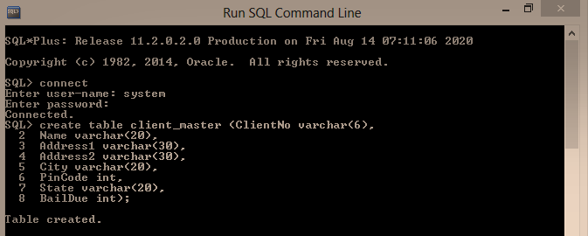

**Table Name: PRODUCT_MASTER Description:** used to store product information

|  |  |  |
| --- | --- | --- |
| **Column name** | **data type** | **Size** |
| PRODUCTNO | Varchar | 6 |
| DESCRIPTION | Varchar | 15 |
| PROFITPERCENT | Decimal | 4,2 |
| UNIT MEASURE | Varchar | 10 |
| QTYONHAND | Integer |  |
| REORDERL VL | Integer |  |
| SELLPRICE | Decimal | 8,2 |
| COSTPRICE | Decimal | 8,2 |

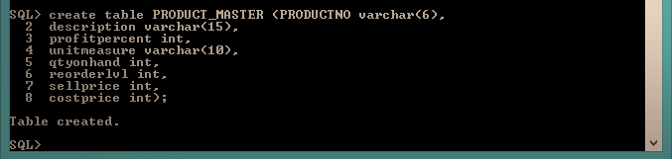

**Table Name: SALESMAN_MASTER**

**Description:** Used to store salesman information working for the company.

|  |  |  |
| --- | --- | --- |
| **Column name** | **data type** | **Size** |
| SALESMANNO | Varchar | 6 |
| SALESMANNAME | Varchar | 20 |
| ADDRESS 1 | Varchar | 30 |
| ADDRESS 2 | Varchar | 30 |
| CITY | Varchar | 20 |
| PINCODE | Integer |  |
| STATE | Varchar | 20 |
| SALAMT | Real |  |
| TGTTOGET | Decimal |  |
| YTDSALES | Double | 6,2 |
| REMARKS | Varchar | 60 |

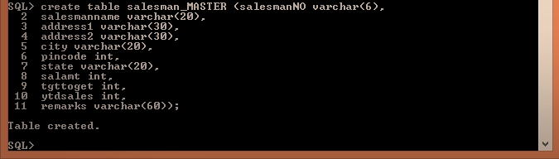

* **Insert the following data into their respective tables:**
* Data for **CLIENT_MASTER** table:

|  |  |  |  |  |  |
| --- | --- | --- | --- | --- | --- |
| Client no | Name | City | Pincode | State | BalDue |
| C00001 | Ivan bayross | Mumbai | 400054 | Maharashtra | 15000 |
| C00002 | Mamta muzumdar | Madras | 780001 | Tamil nadu | 0 |
| C00003 | Chhaya bankar | Mumbai | 400057 | Maharashtra | 5000 |
| C00004 | Ashwini joshi | Bangalore | 560001 | Karnataka | 0 |
| C00005 | Hansel colaco | Mumbai | 400060 | Maharashtra | 2000 |
| C00006 | Deepak sharma | Mangalore | 560050 | Karnataka | 0 |

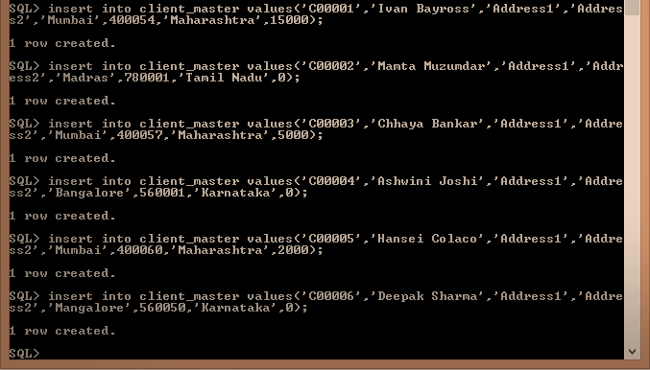

* Data for **PRODUCT**_**MASTER** table:

|  |  |  |  |  |  |  |  |
| --- | --- | --- | --- | --- | --- | --- | --- |
| Product  No | Description | Profit percent | Unit measure | Quantity  On  hand | Recorder  Level | Sell  Price | Cost  Price |
| P00001 | T-Shirt | 5 | Piece | 200 | 50 | 350 | 250 |
| P0345 | Shirts | 6 | Piece | 150 | 50 | 500 | 350 |
| P06734 | Cotton jeans | 5 | Piece | 100 | 20 | 600 | 450 |
| P07865 | Jeans | 5 | Piece | 100 | 20 | 750 | 500 |
| P07868 | Trousers | 2 | Piece | 150 | 50 | 850 | 550 |
| P07885 | Pull Overs | 2.5 | Piece | 80 | 30 | 700 | 450 |
| P07965 | Denim jeans | 4 | Piece | 100 | 40 | 350 | 250 |
| P07975 | Lycra tops | 5 | Piece | 70 | 30 | 300 | 175 |
| P08865 | Skirts | 5 | Piece | 75 | 30 | 450 | 300 |

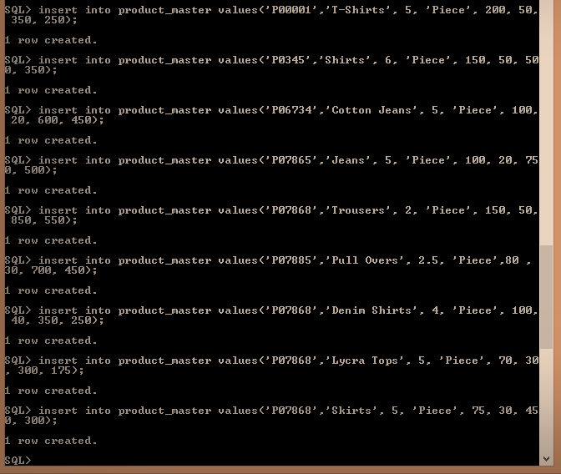

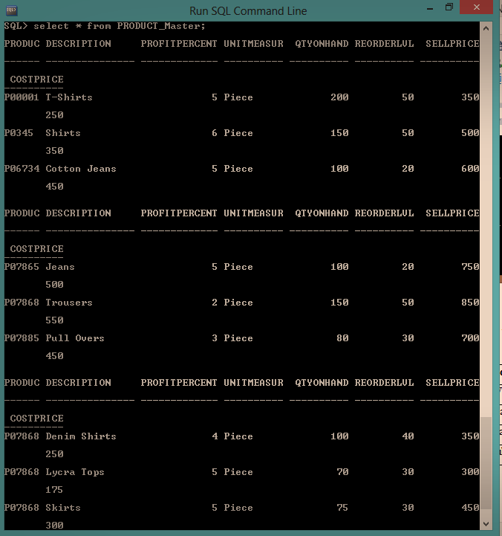

* Data for **SALESMAN_MASTER**  table:

|  |  |  |  |  |  |  |
| --- | --- | --- | --- | --- | --- | --- |
| **Salesman No** | **Name** | **Address1** | **Address2** | **City** | **Pin Code** | **State** |
| S00001 | Aman | A/14 | Worli | Mumbai | 400002 | Maharashtra |
| S00002 | Omkar | 65 | Nariman | Mumbai | 400001 | Maharashtra |
| S00003 | Raj | P-7 | Bandra | Mumbai | 400032 | Maharashtra |
| S00004 | Ashish | A/5 | Juhu | Mumbai | 400044 | Maharashtr(a |

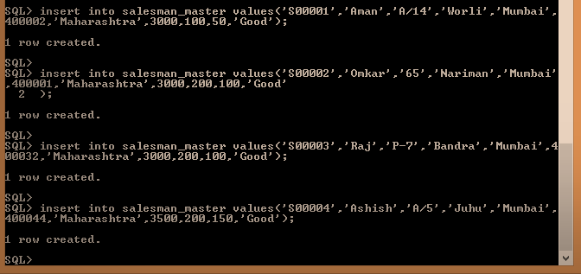

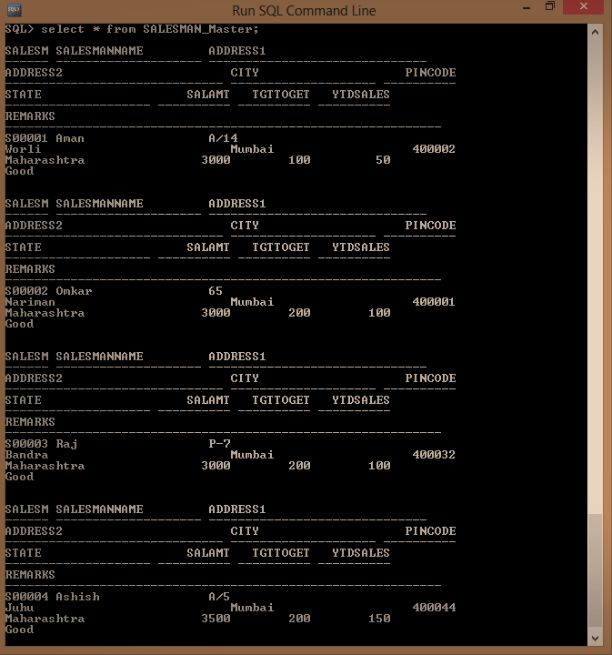

a. Find out the names of all the clients.

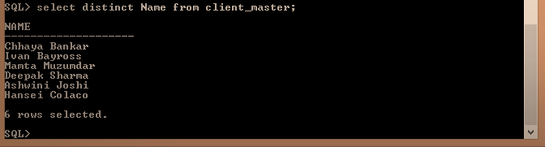

b. Retrieve the entire contents of the Client_Master table.

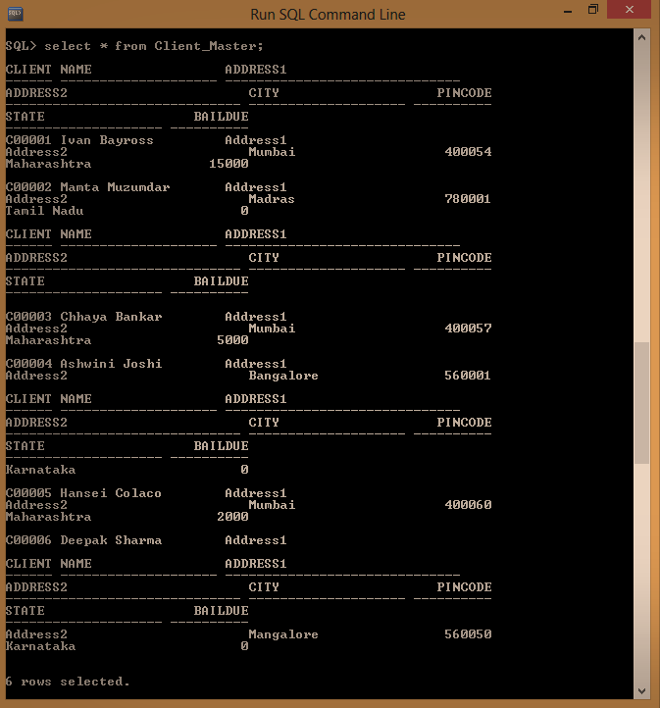

c. Retrieve the list of names, city and the state of all the clients.

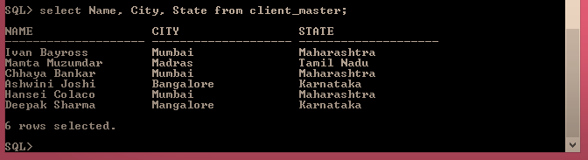

d. List the various products available from the Product_Master table.

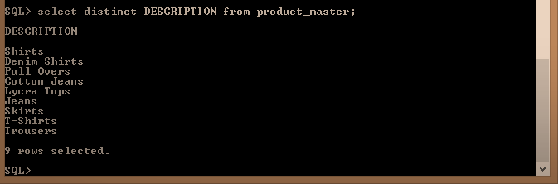

e. List all the clients who are located in Mumbai.

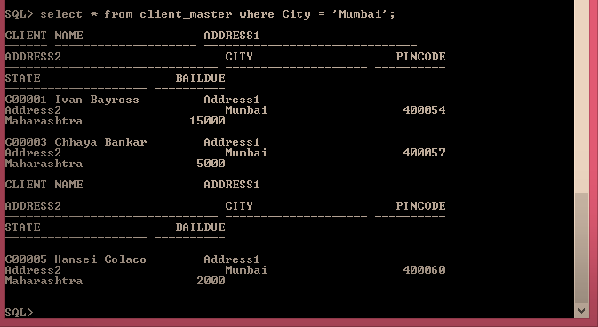

f. Find the names of salesman who have a salary equal to Rs.3000.

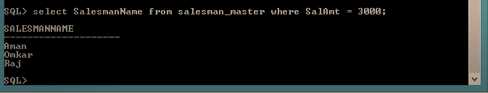

* a. Change the city of ClientNo ‘C00005’ to ‘Bangalore’.



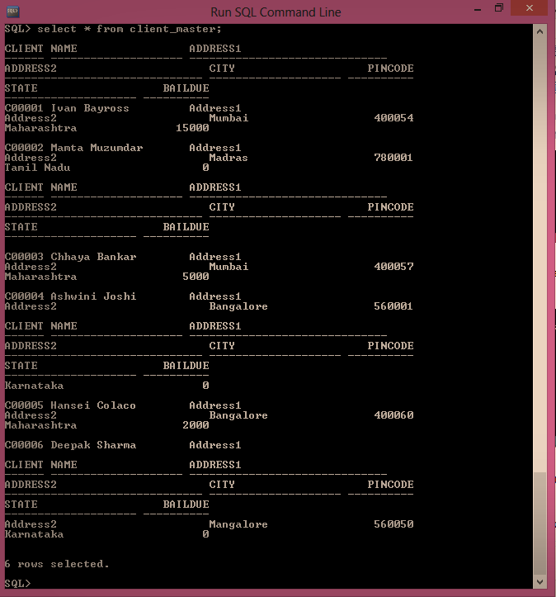

b. Change the BalDue of ClientNo ‘C00001’ to Rs.1000.

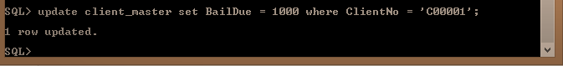

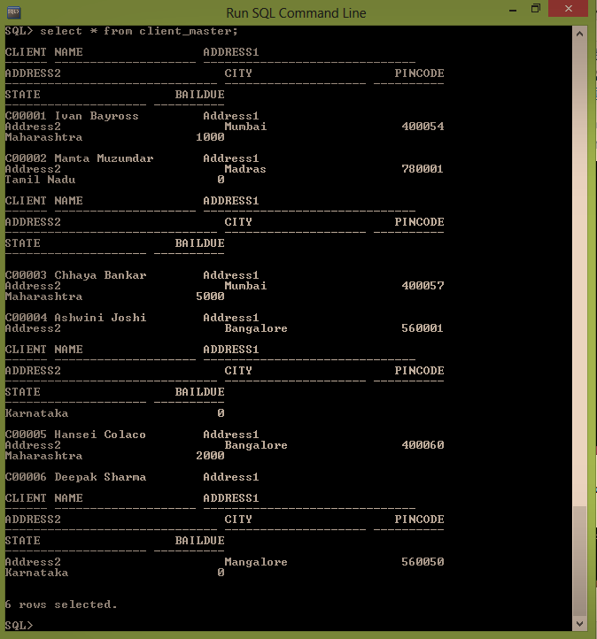

c. Change the cost price of ‘Trousers’ to rs.950.00.

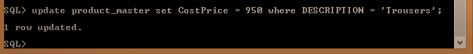

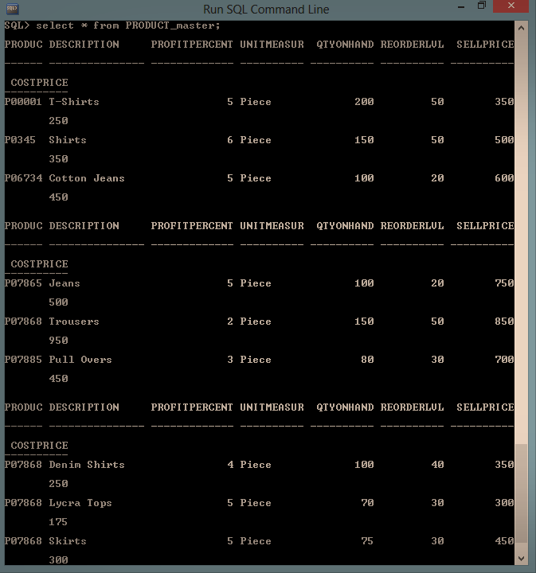

d. Change the city of the salesman to Pune.

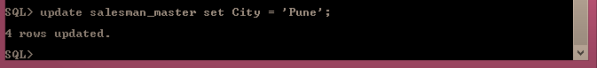

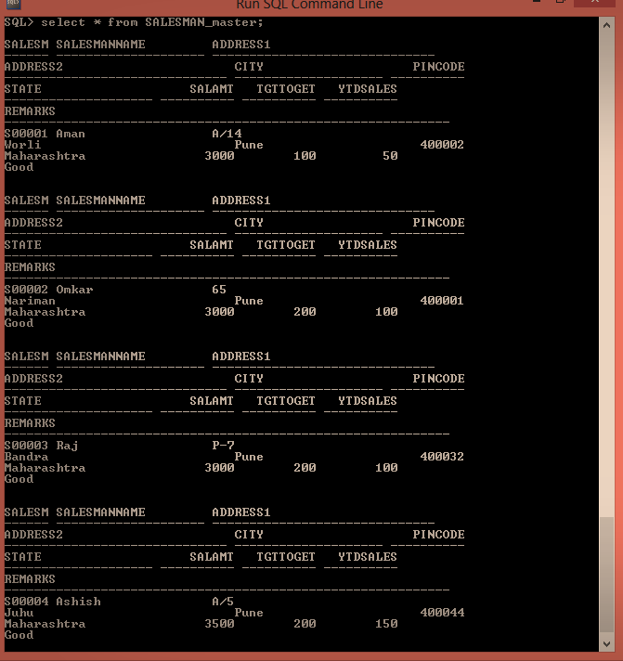

* a. Delete all salesman from the Salesman_Master whose salaries are equal to Rs.3500.

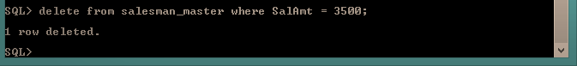

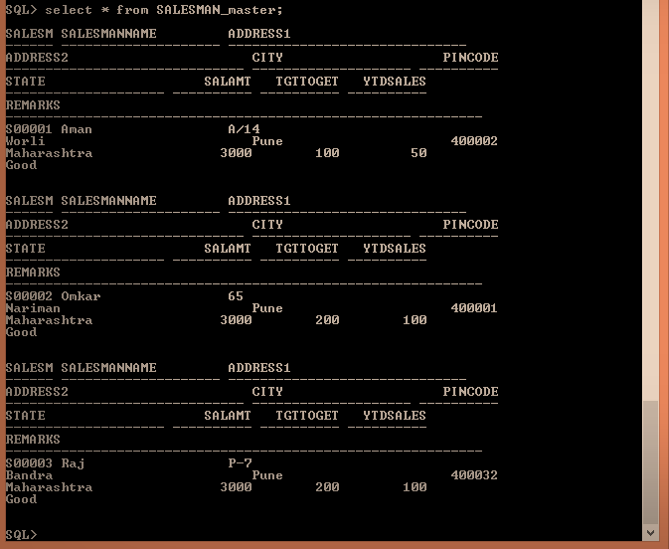

b. Delete all products from Product_Master where the quantity on hand is equal to 100.

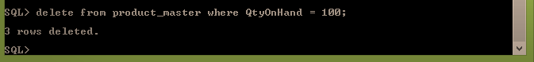

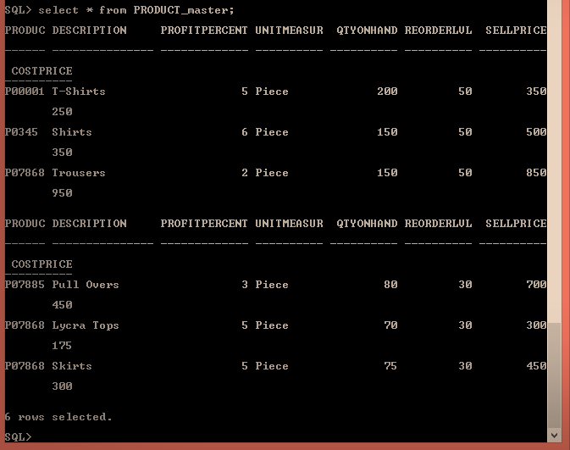

c. Delete from Client_Master where the column state holds the value ‘Tamil Nadu’.

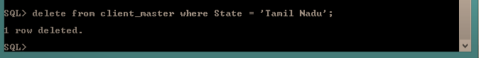

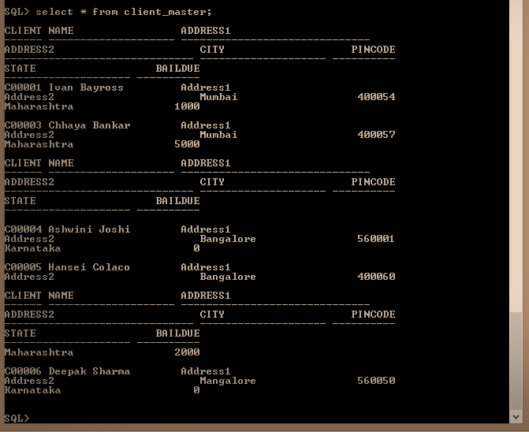

* a. Add a column called ‘Telephone’ of data type integer to the Client_Master table.

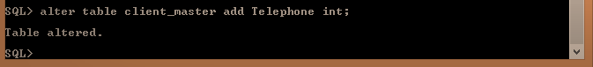

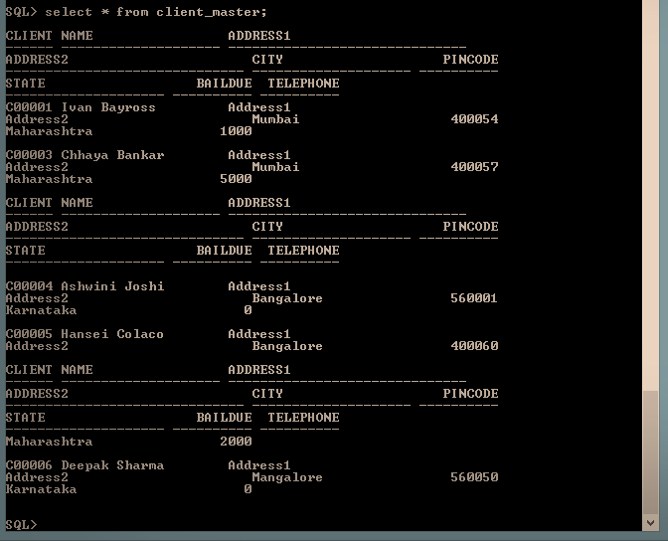

b. Change the size off SellPrice column in Product _Master to 10, 2.

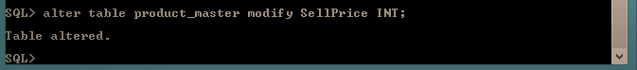

a. Destroy the table Client_Master along with its data.

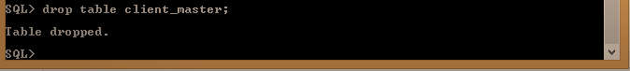

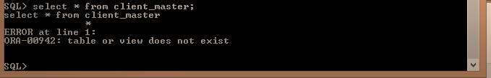

* a. Change the name of the Salesman_Master to sman_mast.

